Montreux Jazz Festival China 2023 Festival Poster
Designed by: Sean Xiang (China)

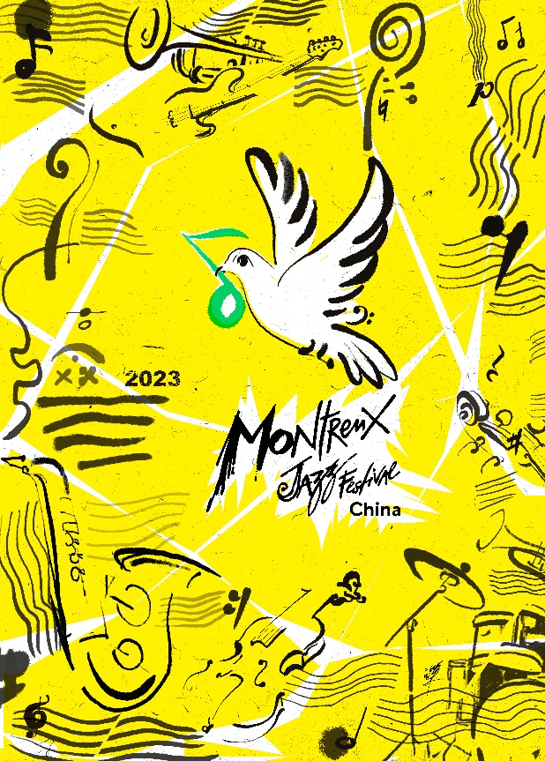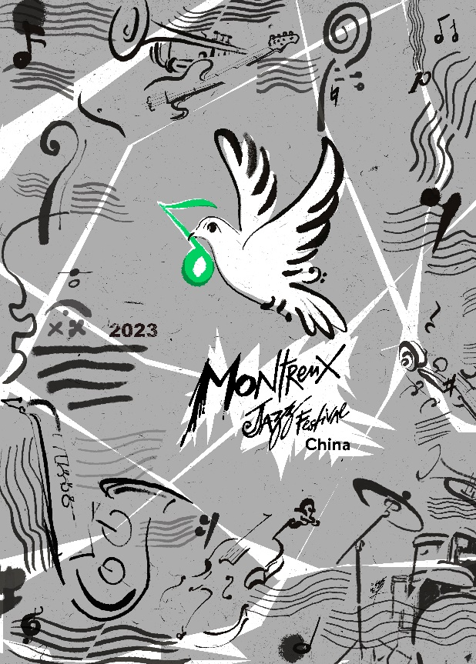
Bright Yellow Version Silver Version

After a Silent Lake in 2022, we couldn’t wait to restart in 2023. The dove in the center of the poster brings a green note to the world, giving people the hope of Revival, which is the theme of our festival in 2023. Let’s look forward to the festival in celebration of music, life, and love!

Poster Design Concept

- The main elements of the image use familiar musical instruments such as the violin, saxophone, trumpet, cello, and the percussion instrument. They reflect the theme and tonality of the festival and use oriental ink and wash hand-painting techniques to show its profound cultural characteristics.

- The bending curve is like a split stave, or a turbulent wave, with all kinds of deconstructed musical instruments placed in different positions, implying that the pandemic and other global events are like a tsunami hitting the world.

- The dove in the center of the poster brings a green note of hope to the people and a message of Revival.

- The overall picture adopts the scatter-point layout of Chinese painting skills, with various elements scattered and reconstituted, striving to create a smart and lively sense of rhythm.

- Sensitive hand-painted brushwork and rational geometric lines create a contrast in the picture, expressing the contradictions and impacts of the various forces during the Revival.

- There are two versions of the poster. Yellow version: bright yellow with a large area of fluorescent light, stimulating, eye-catching and refreshing, and attracting attention just like the music of the Montreux Jazz Festival China which brings people joy and hope. Silver version: It has a metallic texture and does not have any color tendency. It is a very technological and rational color. It is presented together with warm musical elements, which can create an artistic tension and make it more fashionable and attractive.

About the Creator

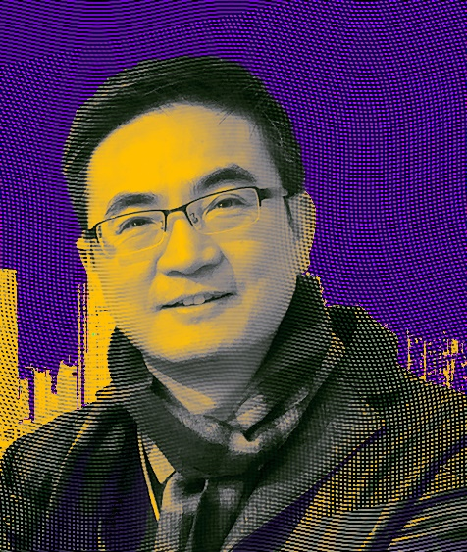

Sean Xiang is a Shanghai-based comprehensive art creator, graphic designer, photographer, and curator. A former official media art director of the Shanghai World Expo, he is now the curator and senior art designer of the World Expo Museum.

He is also the director of the Shanghai Creative Design Workers Association, a member of the Shanghai Visual Communication Professional Committee, a member of the Shanghai Packaging Design Committee, and a member of Shanghai Photographers Association.

He is mainly engaged in art design, artistic creation, exhibition planning and design management, and has been covered by more than 100 major media outlets.

He graduated from the Fine Arts Department of the Shanghai Light Industry College and the Art Department of the East China Normal University. From 2006 to 2011, he worked in the Shanghai World Expo, the only official media of the 2010 Shanghai World Expo in China, as the art designer and art director.

Major Honors and Achievements:

- Presided over the series of visual communication design for the World Expo commemorative exhibition hosted by the Shanghai Municipal Government;

- Designed the Logo and overall visual design of the "Charity Stars" global awards ceremony for Dragon TV;

- Designed visual materials such as the main logo and a series of promotional posters for CCTV's "Song of China" program;

- Designed the overall image and all relevant materials for the Lishui World Expo International Forum;

- Presided over the design of the cultural space in the "World Expo Station" station of Metro Line 13. Since its opening to the public, it has served more than 50 million passengers;

- Curator of the "Powering the Future - Special Exhibition of Expo 2017 Astana" and "International Poster Exhibition";

- Created the theme sculpture of "Happy Gathering - Connection" for Shanghai Cultural Space;

- Presided over the visual design work of the series of "Dancing and Colorful - The Fifth Anniversary of the World Expo";

- Xiang’s work "Dream back home" was selected for the 2018 New York Digital Photography Salon;

- His comprehensive media work "Surging" was selected and participated in the "2022 Awakening of Insects - Chinese Contemporary Art Exhibition";

- Xiang’s comprehensive media visual work "Galaxy of splendor" and many other works were selected for the 10th Anniversary Creative Design Exhibition of Shanghai "Design Capital".

Representation and design of products
